Strategic Decision-Making using Power BI

Pre-Report Submission

Submitted to- Dr. ARPIT YADAV

Name: BISHAL KUMAR SHAW

Reg. No.: 2023JULB01220

Table Of Content

* Problem Statement ……………………………………………………………1
* Data Requirement ……………………………………………………………..2
* Data Collection …………………………………………………………………3
* Data Validation ………………………………………………………………….4
* Data Cleaning ……………………………………………………………………5
* Tools ………………………………………………………………………………..6
* Dashboard ………………………………………………………………………..7
* Storytelling ………………………………………………………………………..8

1. PROBLEM STATEMENT

**Objective:**

To contribute to the success of the supermarket business by leveraging data analysis techniques, specifically time series analysis, to derive actionable insights and accurate sales forecasting for better decision-making.

**Proposed Approach:**

Dashboard Creation

Design an intuitive and visually appealing dashboard with interactive features to let users explore the data in depth.

Data Analysis

Evaluate the effectiveness of sales strategies and identify trends to enhance performance.

Sales Forecasting

Use time series analysis on historic data to forecast sales for the next 15 days.

Actionable Insights and Recommendations

Provide strategic recommendations to drive growth, efficiency, and customer satisfaction.

Expected Outcomes

To deliver valuable insights that aid in reducing costs, improving sales strategies, and achieving customer satisfaction across different regions and categories.

2. DATA REQUIREMENT

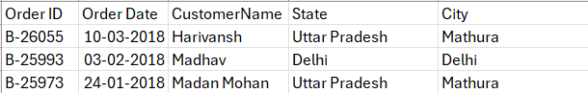

Provided dataset including details on orders, shipping, customer demographics, and financial performance.

Required Columns:

Order ID - Unique identifier for each order.

Order Date - Date when the order was placed.

Customer Name – Name of Customer.

State – Name Of State.

City – Name of City.

Amount - Total value.

Profit - Profit Amount.

Quantity – Number of Units.

Category- Type of Product.

Sub- Category- Exact Product

Payment Mode - Payment method used.

3. DATA COLLECTION

Sales Reports

Compiled from the supermarket’s backend systems with relevant sales data and customer information.

Market Segmentation

Segmentation based on regions, demographics, and sales trends to assess geographical performance.

Product Analysis

Detailed SKU-level data for analysis of demand, pricing, and profit margins.

4. DATA VALIDATION

**Purpose**

Ensuring data reliability by checking for missing values, inconsistencies, and duplicate records.

**Validation Steps:**

Missing Values

Impute missing values or exclude records where data is incomplete.

Data Consistency

Standardize formats for dates, locations, and other categorical data.

Duplicate Records

Remove duplicates to avoid inaccurate analysis.

Range Validation

Confirm all values are logical, e.g., positive sales amounts.

5. DATA CLEANING

Handle Missing Data

Replace missing values or remove rows with essential missing data.

Correct Data Formats

Convert date fields to a uniform format (e.g., MM-DD-YYYY) and standardize text fields.

Filter Outliers

Remove unreasonable values in sales or profit fields.

Consolidate Data

Merge similar categories for streamlined analysis.

6. TOOLS

Power BI - Used for creating interactive dashboards and conducting in-depth data analysis.

Excel - Employed for preliminary data validation and cleaning.

7. DASHBOARD

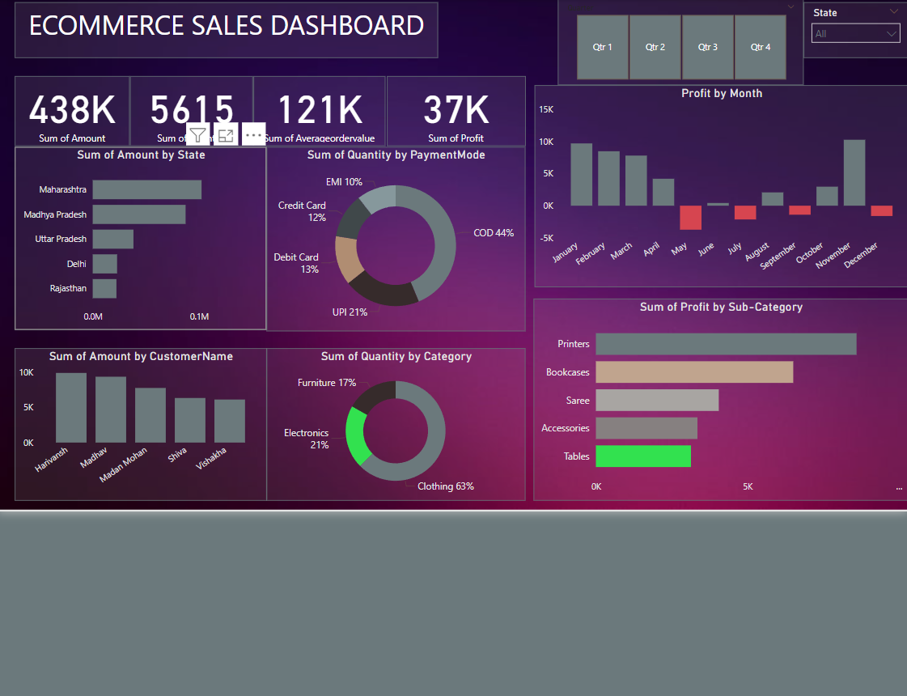

**Key Components of the Power BI Dashboard**

Sales Performance Overview

Breakdown of total sales by region, category, and payment method.

Insights into high-performing and low-performing categories.

Cancellation and Return Analysis

Trends in order returns and cancellations by category and region.

Delivery Performance

On-time delivery rates and their impact on customer satisfaction.

Revenue and Profit Trends

Monthly and quarterly growth rates, with insights into top products and regions by revenue.

Sales Forecasting

15-day sales projections using historical data and time series analysis.

8. STORYTELLING

Introduction

Present the dataset's scope and primary analysis objectives.

Challenges Identified

Low-performing categories in specific regions.

Delivery and cancellation issues affecting customer satisfaction.

Key Insights

Observed trends in sales, cancellations, and returns, with a focus on seasonal fluctuations and regional variations.

Recommendations

Optimize marketing efforts in regions with high sales potential.

Streamline fulfillment processes to reduce cancellations and improve delivery times.

Adjust stock levels for high-demand items to maximize availability and minimize returns.